Aws Vpc Task
- Create VPC with 2 private and 2 public subnets.
First create vpc
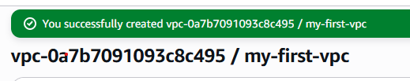
Create two public and two private subnet

- Enable DNS Hostname in VPC.
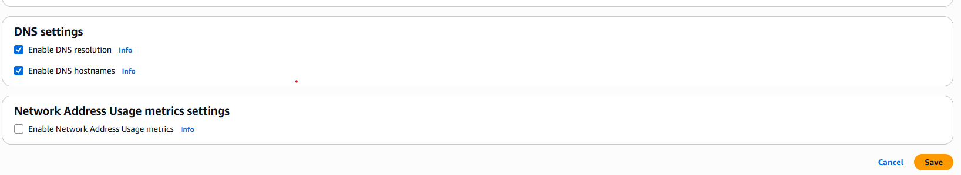

- Enable Auto Assign Public IP in 2 public subnets.
Public subnet 1
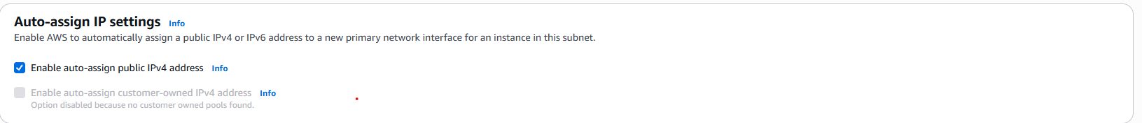
Public subnet 2

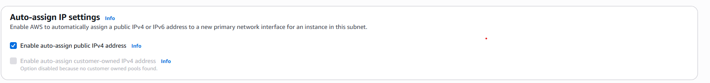

- Add 2 private subnets in private route table.
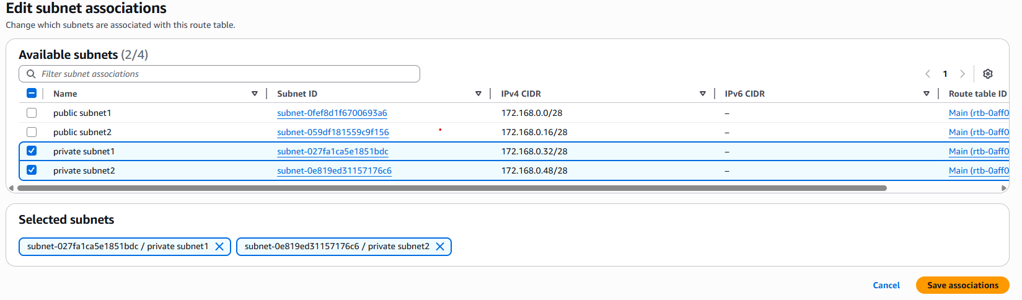
- Add 2 public subnets in public route table.
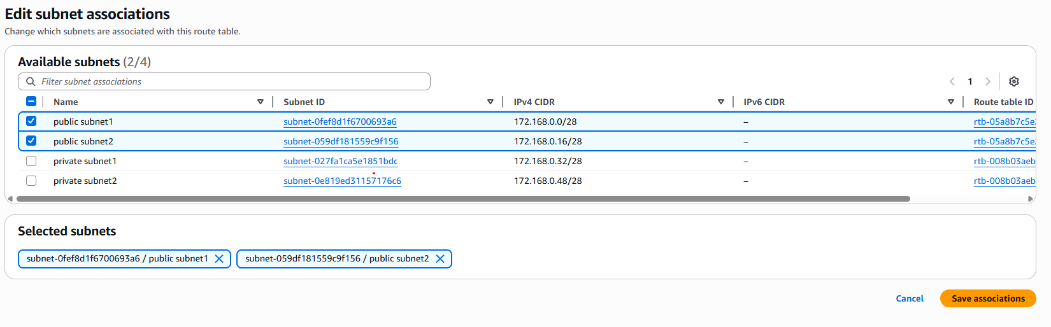
- Public route table will have the routes to internet and local.
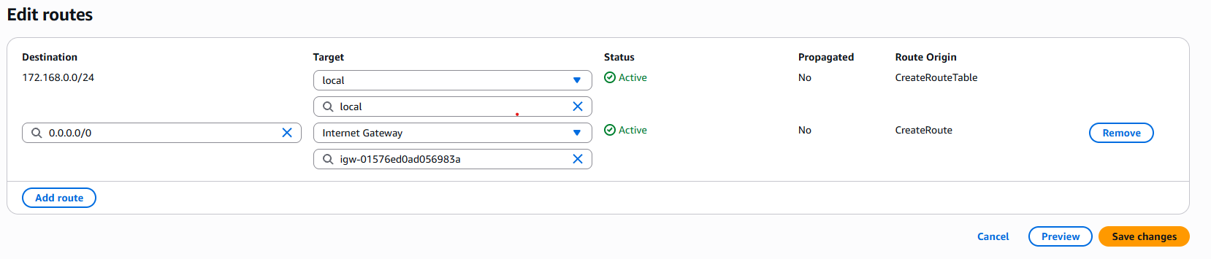
- Create EC2 in public subnet with t2.micro and install PHP.
First Install Httpd :
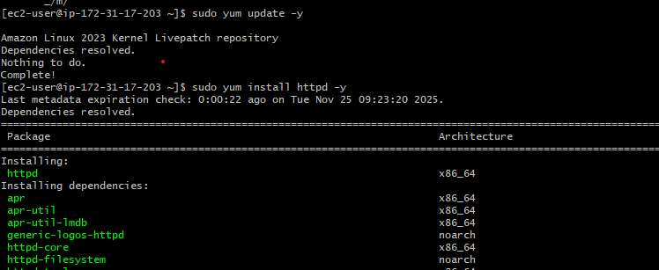

Install Php: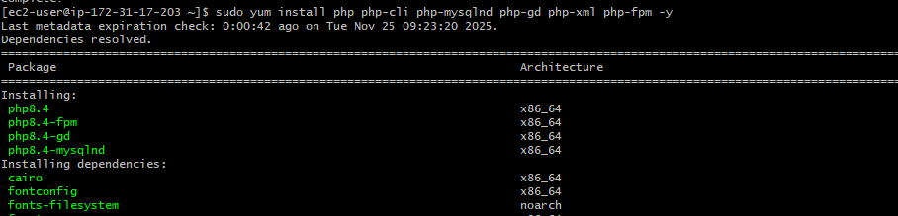
Php info file:
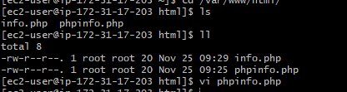
http://<Public_IPv4_address>/info.php
http:// 54.183.78.223/info.php

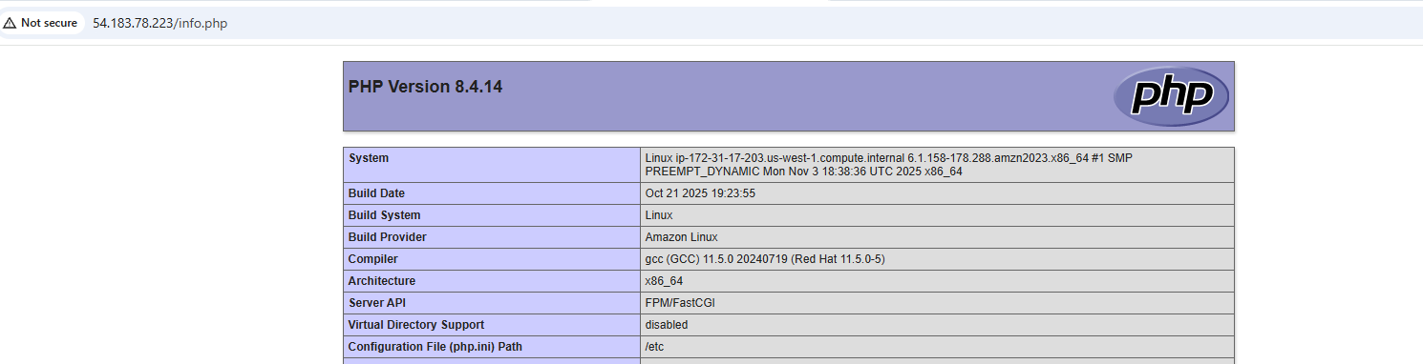

8.Configure NAT gateway in public subnet and connect to private instance.
Create NAT gateway in public subnet.
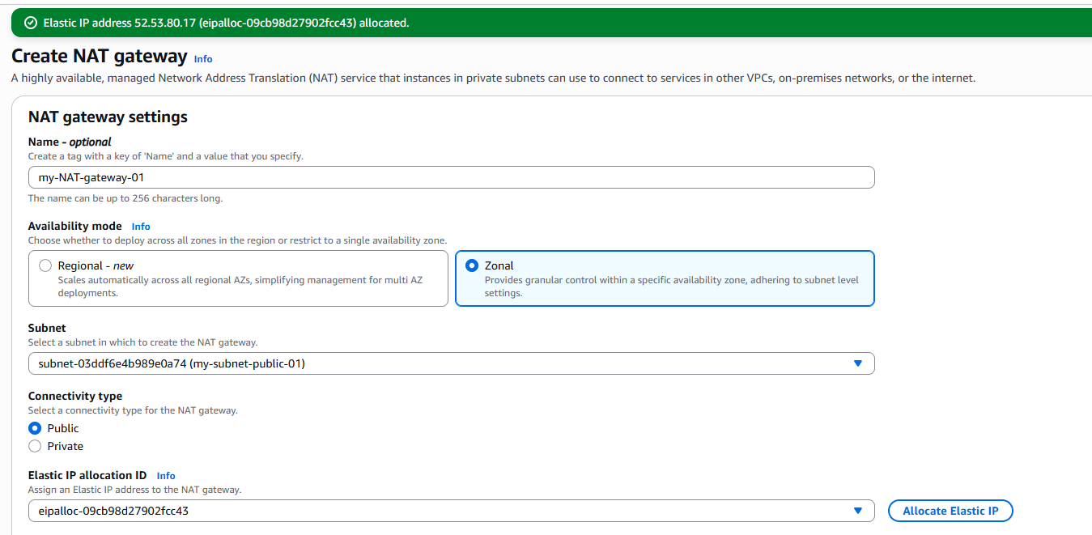

Create access to public ec2 to private ec2
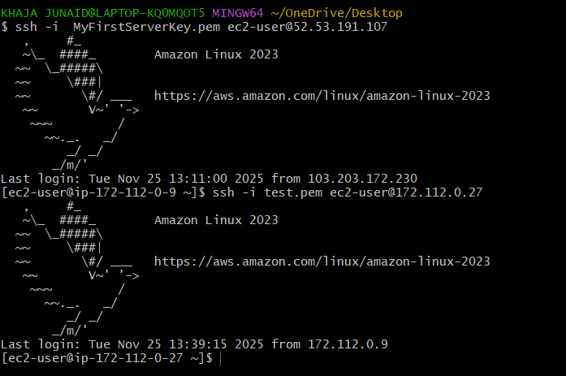

Create internet connection in ec2 private instance with the help NAT Gateway.
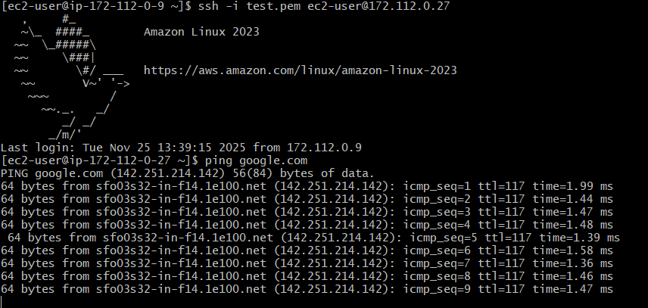

- Install Apache Tomcat in private EC2 and deploy a sample app.
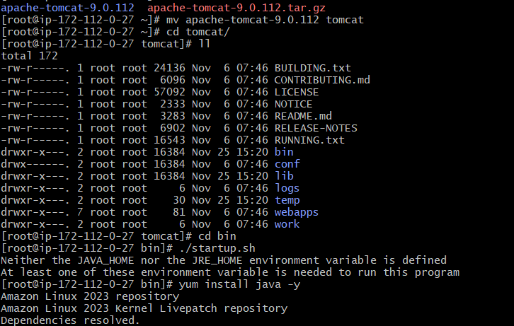

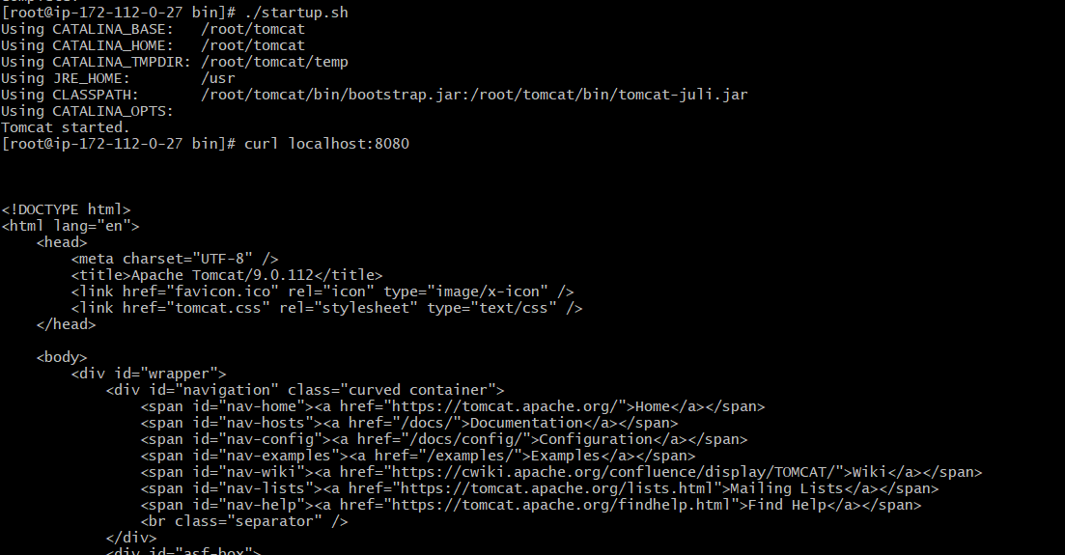

- Configure VPC flow logs and store the logs in S3 and CloudWatch.
